Review:
Test Run: US32200_Windows_Enhance offline experience + action buttons always visible on the WO card v.2
Status: Completed

Produced by Kaustubha Ramdasi (550020993), 03/25/2026

Overview
v.2 Start date: 12/11/2025
v.2 End date: 12/12/2025 02:07:14 PM UTC
Moderator(s): Sandeep Udayasingh (550005443)

Review participants
Name | Review role | Signature meaning | Status
Ramya Ragupathy (503236271) | Approver | I approve the content of this review. | In Progress
Rubeena Syed ( 550003347) | Approver | I approve the content of this review. | In Progress
Aishwarya Gupta (550021178) | Approver | I approve the content of this review. | In Progress
Ghouse Khan (550021182) | Approver | I approve the content of this review. | In Progress
Subhadip Halder (550021133) | Approver | I approve the content of this review. | Signature authenticated: 12/12/2025 11:56:50 AM UTC
Kadambini Ray (550021957) | Approver | I approve the content of this review. | In Progress
Kaustubha Ramdasi (550020993) | Approver | I approve the content of this review. | In Progress
Kavitha Battu (550003532) | Approver | I approve the content of this review. | In Progress

Items reviewed

US32200_Windows_Enhance offline experience + action buttons always visible on the WO card

DESCRIPTION
To improve offline usability, Field Engineers will see
visual indicators on each Work Order (WO) for offline
availability and pending sync status.
2. A numeric badge on the Sync button shows the count
of WOs awaiting synchronization.
3. WO cards/lines display either a “saved offline” icon (for
downloaded but unmodified WOs) or a “pending sync”
icon (for modified WOs awaiting sync)—never both.

FIELDS
Field | Content
Item Type | Test Run
Test Plan | FX2_GxP-TSTPL-21 2025.6 Windows
Test Cycle | FX2_GxP-TSTCY-17 2025.6_Windows
Test Group | Default Test Group
Test Case | FX2_GxP-DTTS-1625 US32200_Windows_Enhance offline experience + action buttons always visible on the WO card
Test Environment
Steps | 1: Login into Fx2 Smax Windows application with <SSO>, Login into Fx2 Smax Windows application with <SSO>, RequiresObjectiveEvidence: Yes, Passed, User was able to login into Fx2 Smax Windows application with <700001744>  Login Date, Time and Time Zone was recorded as 11-Dec-2025 07:14 pm IST  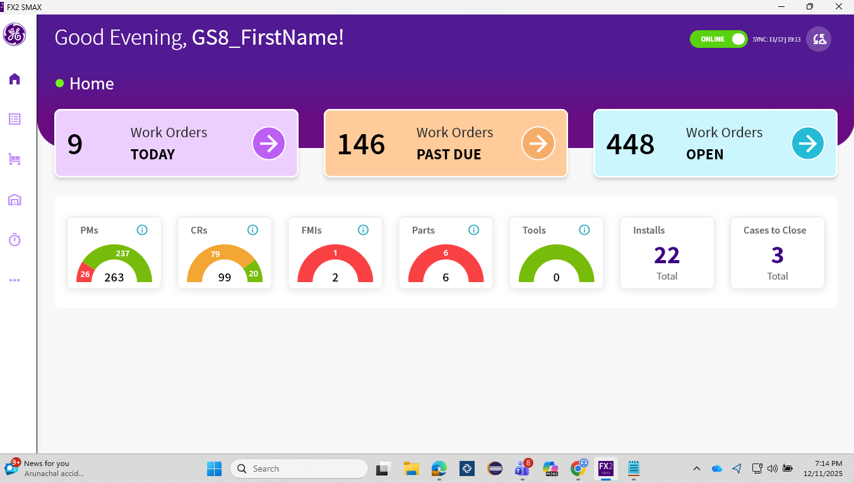  2: Verify user selects the work order <WO> from Open tab and navigates to Details page., Verify user selects the Work Order <WO> from Open tab and navigates to Details page., RequiresObjectiveEvidence: Yes, Passed, User was able to select the Work Order <WO-17362885> from Open tab and navigates to Details page.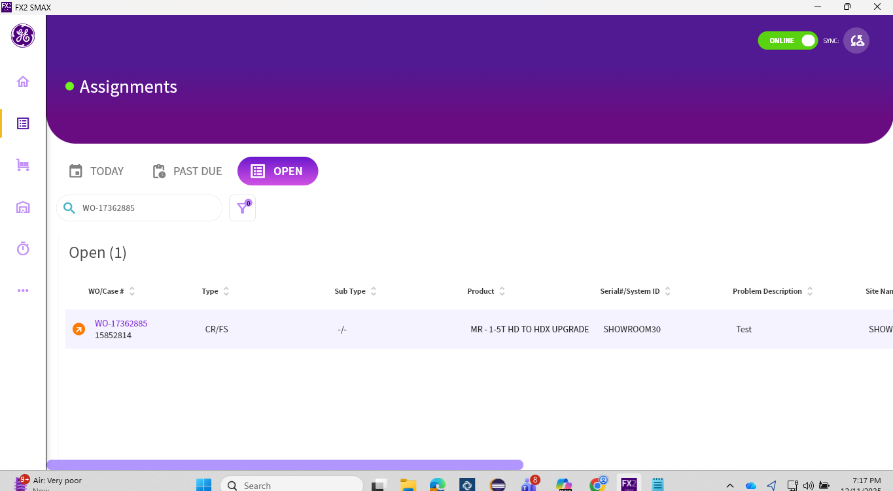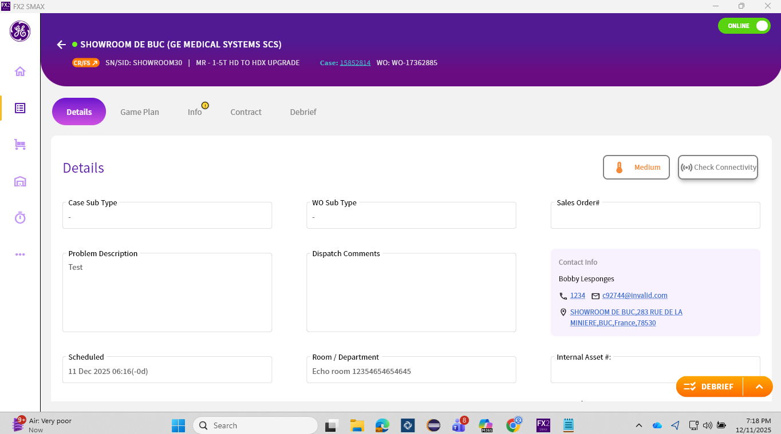  3: Verify user clicks on back button to return back to assignment list page., User should be returned back to assignment list page., RequiresObjectiveEvidence: Yes, Passed, User should be returned back to assignment list page.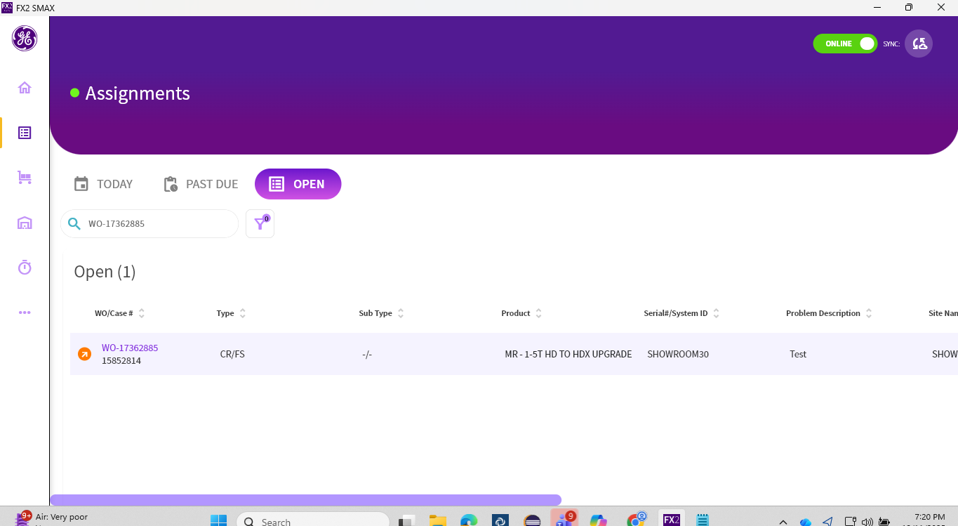  4: Now user turns the application online mode to offline., The application should be turned to offline mode., RequiresObjectiveEvidence: Yes, Passed, The application should be turned to offline mode.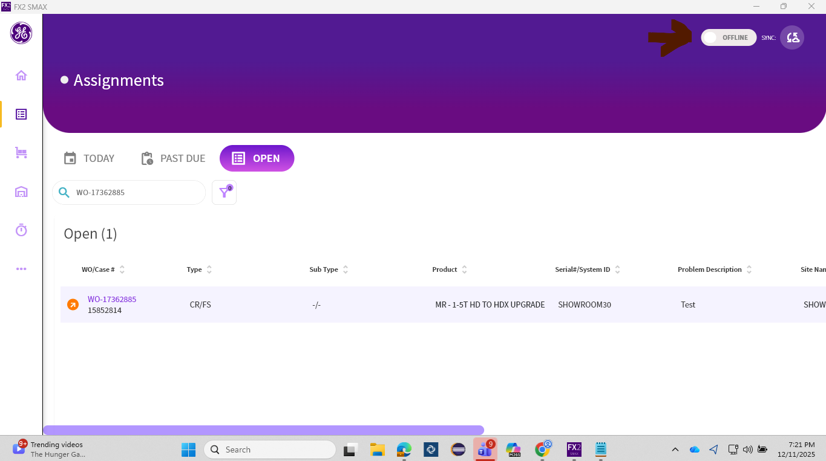  5: Verify the downloaded WO is showing in assignment page and a cloud icon is shown on top right of the WO card., User should be able to verify the downloaded WO was shown and a cloud icon was shown on right of WO card., RequiresObjectiveEvidence: Yes, Passed, User was able to verify the downloaded WO was shown and a cloud icon was shown on right of WO card. 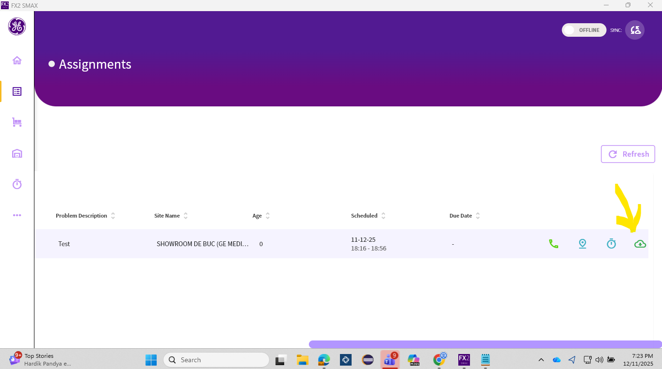  6: Verify user clicks on the WO card and verify WO details page is displayed., User should be able to verify WO details page is displayed., RequiresObjectiveEvidence: Yes, Passed, User was able to verify WO details page was displayed.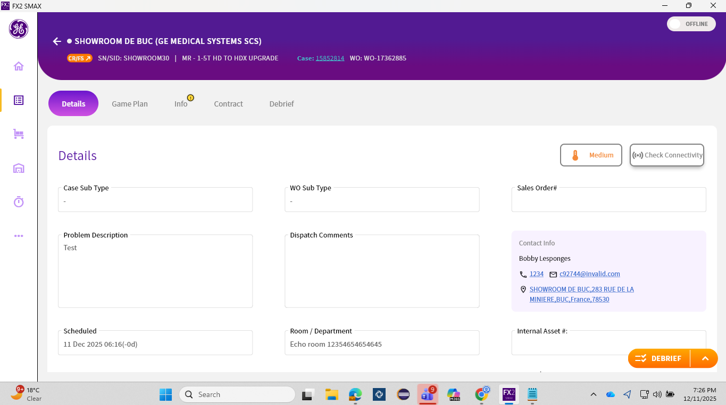  7: Verify user is able to add a note and save it., User should be able to add a note and save it., RequiresObjectiveEvidence: Yes, Passed, User was able to add a note and save it.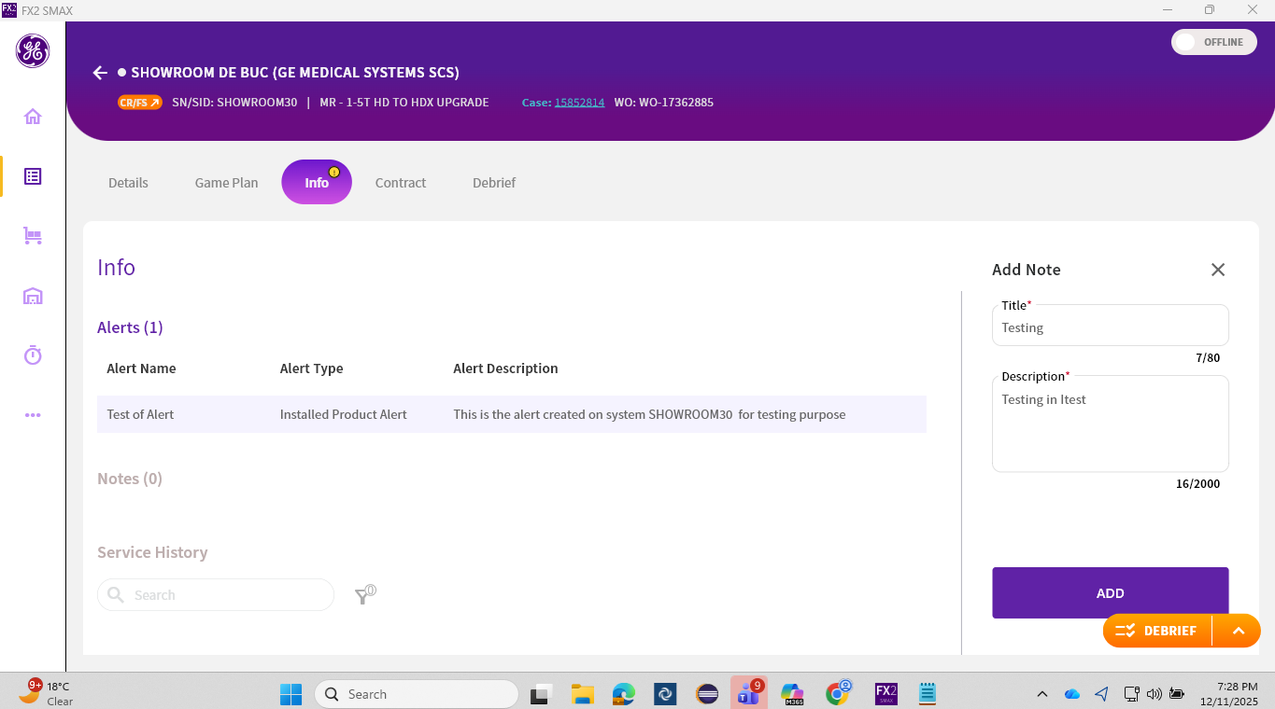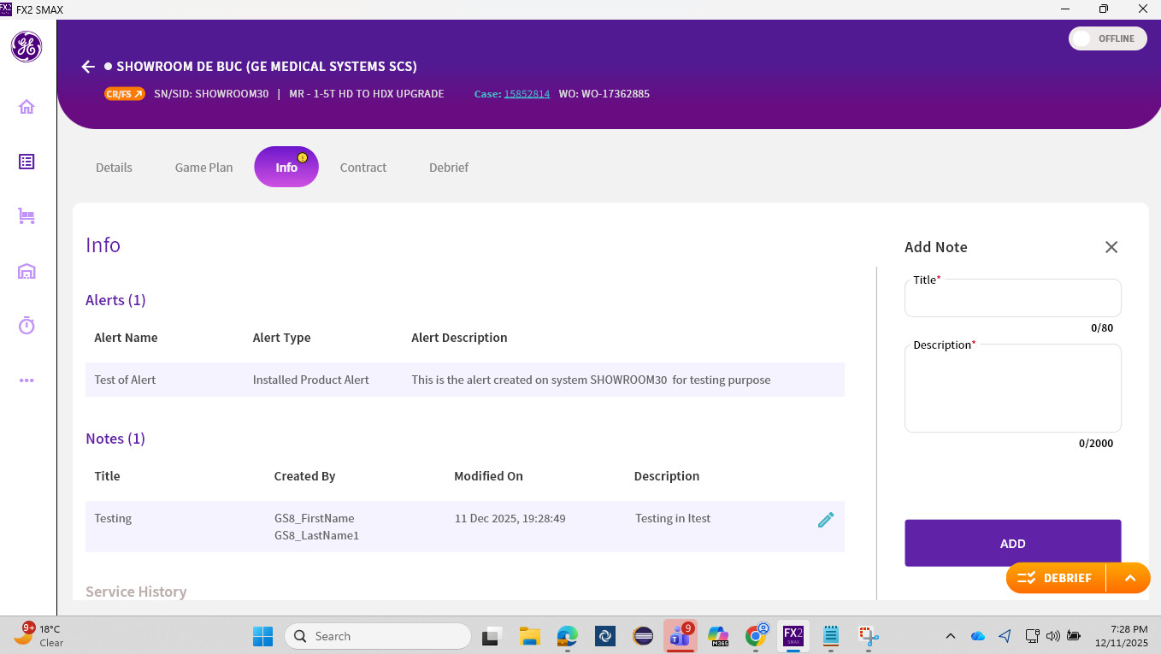  8: Verify user navigate back to assignment page and verify in the WO card cloud icon is replaced by pending sync icon., User should be able to verify in the WO card cloud icon was replaced by pending sync icon., RequiresObjectiveEvidence: Yes, Passed, User was able to verify in the WO card cloud icon was replaced by pending sync icon.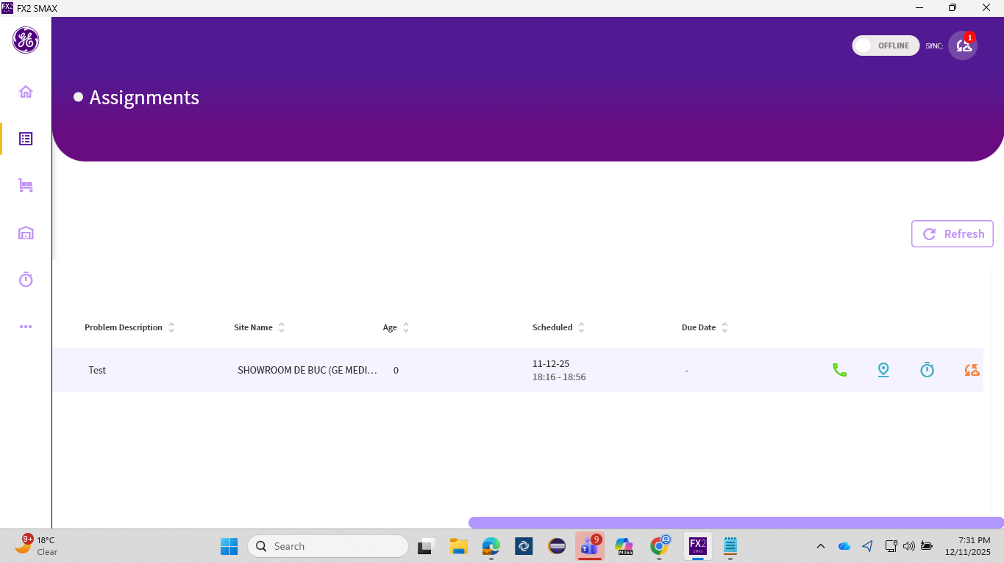  9: Verify user turns offline mode to online., User should be able to turn offline mode to online., RequiresObjectiveEvidence: Yes, Passed, User was able to turn offline mode to online.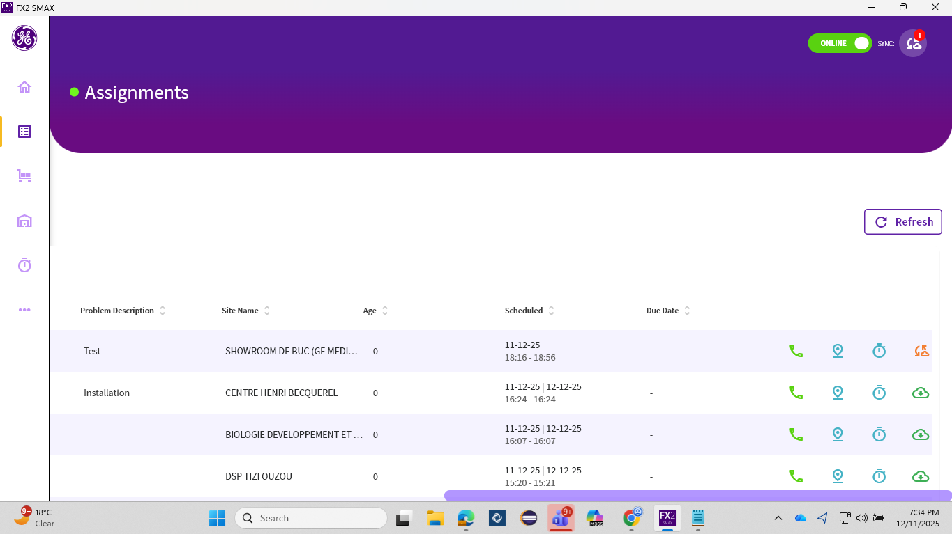  10: Verify in the assignment page on top right corner sync icon is shown with "1" displayed in red color., User should be able to verify in the assignment page on top right corner sync icon is shown with "1" displayed in red color., RequiresObjectiveEvidence: Yes, Passed, User was able to verify in the assignment page on top right corner sync icon was shown with "1" displayed in red color.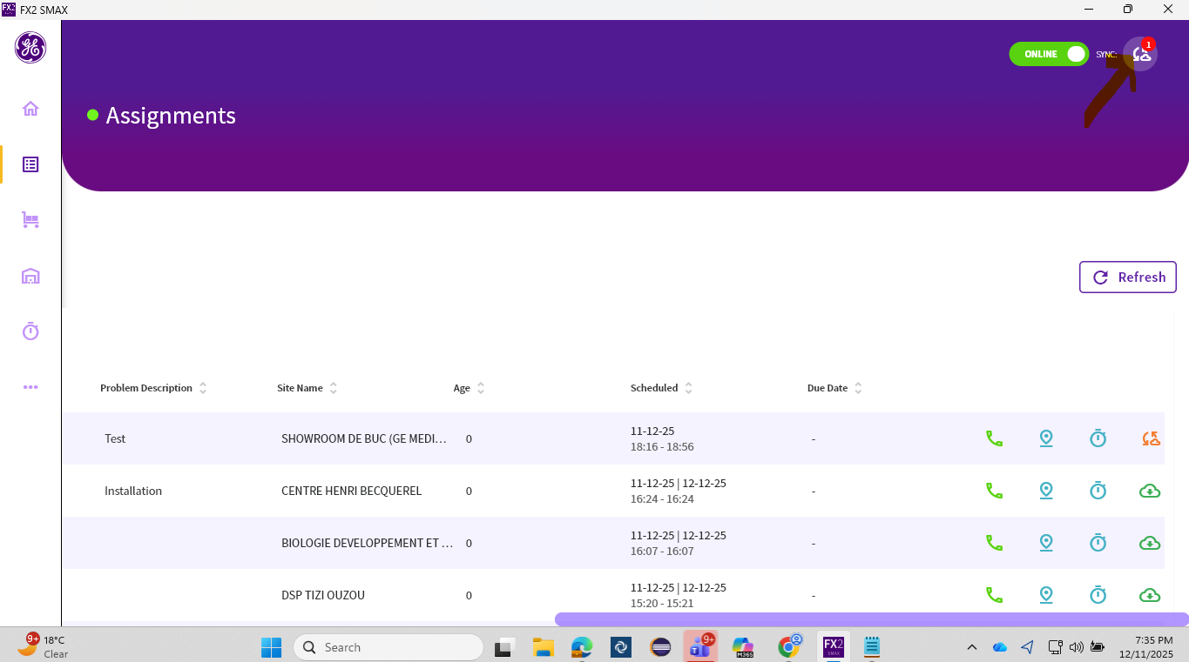  11: Verify user clicks on the Sync icon and sync page is displayed., User should be able to click on the Sync icon and sync page should displayed., RequiresObjectiveEvidence: Yes, Passed, User was able to click on the Sync icon and sync page was displayed.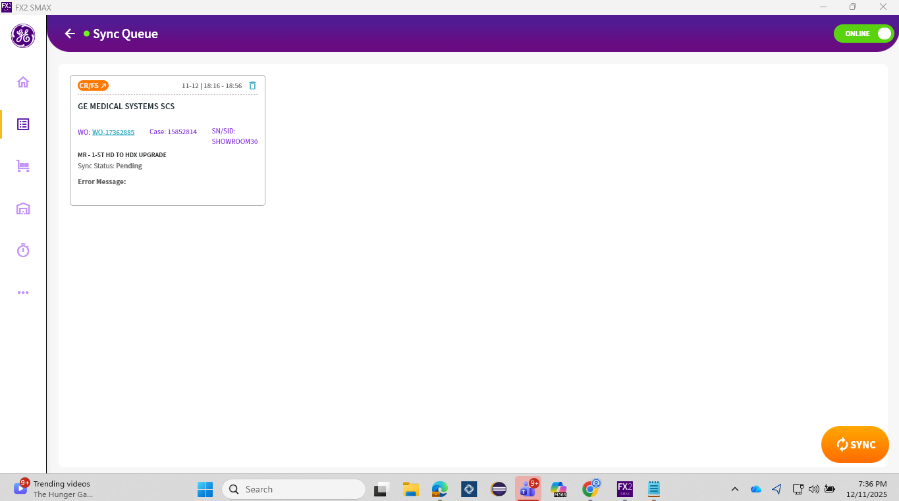  12: Verify in Sync page verify the WO card is displayed and it is pending for sync., User should be able to verify in Sync page verify the WO card should be displayed and it should be pending for sync., RequiresObjectiveEvidence: Yes, Passed, User was able to verify in Sync page verify the WO card was displayed and it was pending for sync.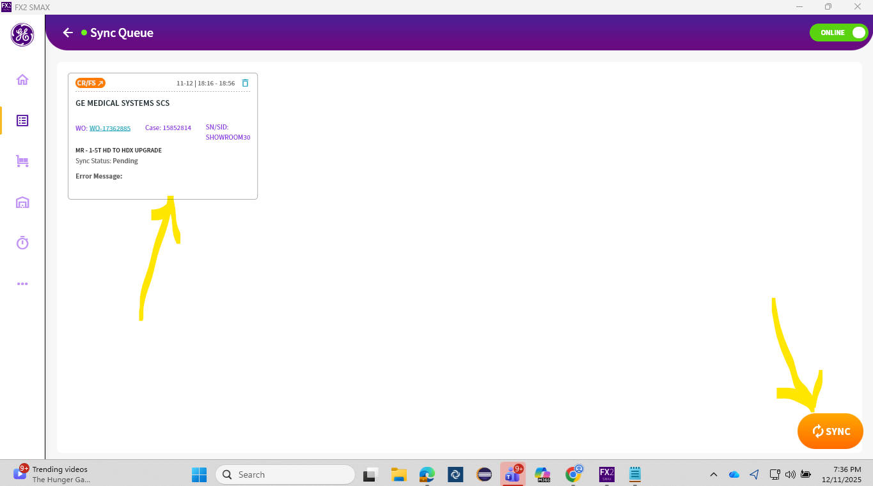  13: Verify user clicks on orange color sync button on bottom right to sync the Work order., User should be able to Sync the Work order successfully., RequiresObjectiveEvidence: Yes, Passed, User was able to Sync the Work order successfully.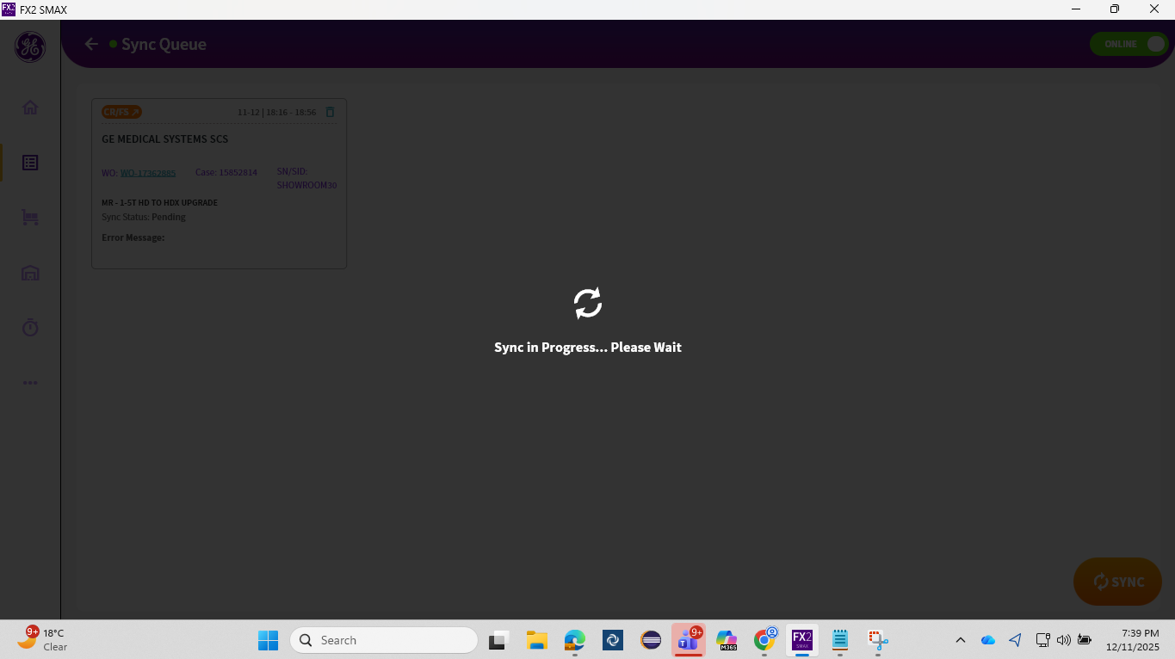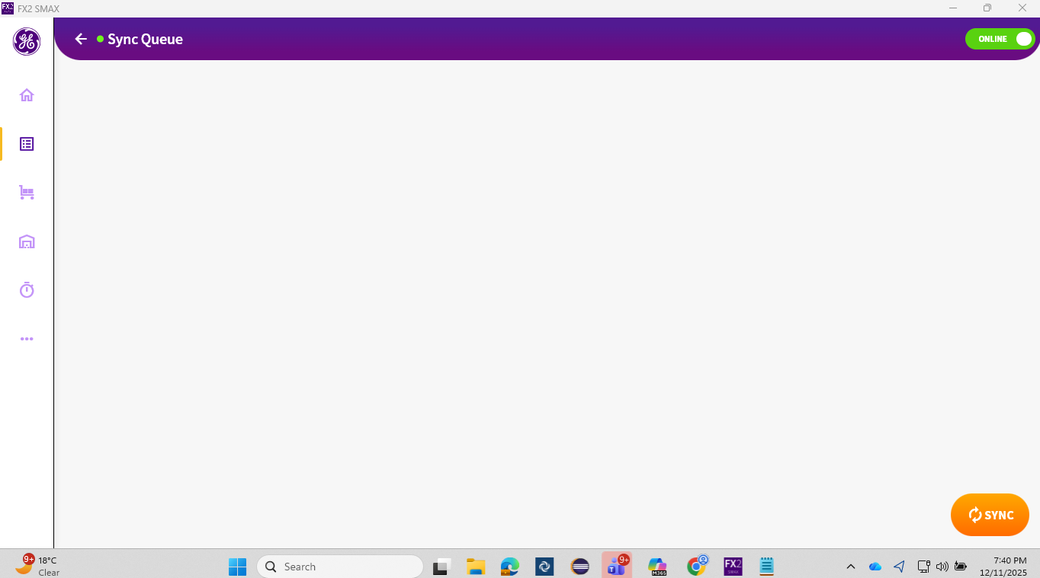  14: Verify user Navigate back to assignment page and select the same WO <WO>, User should be able to select the same WO <WO>, RequiresObjectiveEvidence: Yes, Passed, User should be able to select the same WO < WO-17362885>  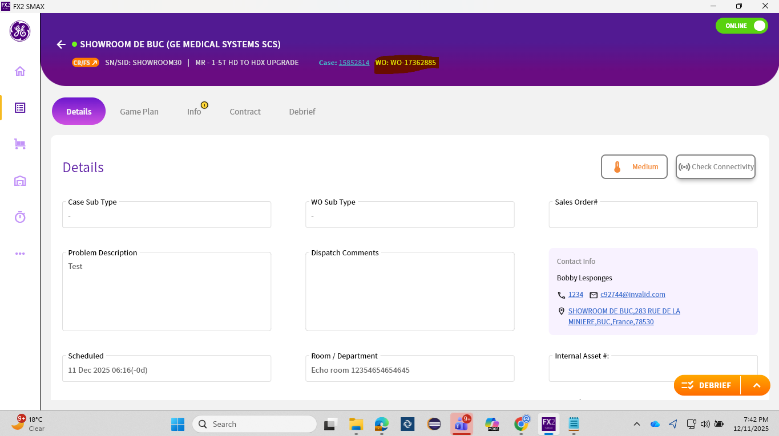  15: Verify user navigate to info page and verify the added note is synced and changes are reflecting, User should be able to verify the added note is synced and changes are reflecting., RequiresObjectiveEvidence: Yes, Passed, User was able to verify the added note was synced and changes were reflecting.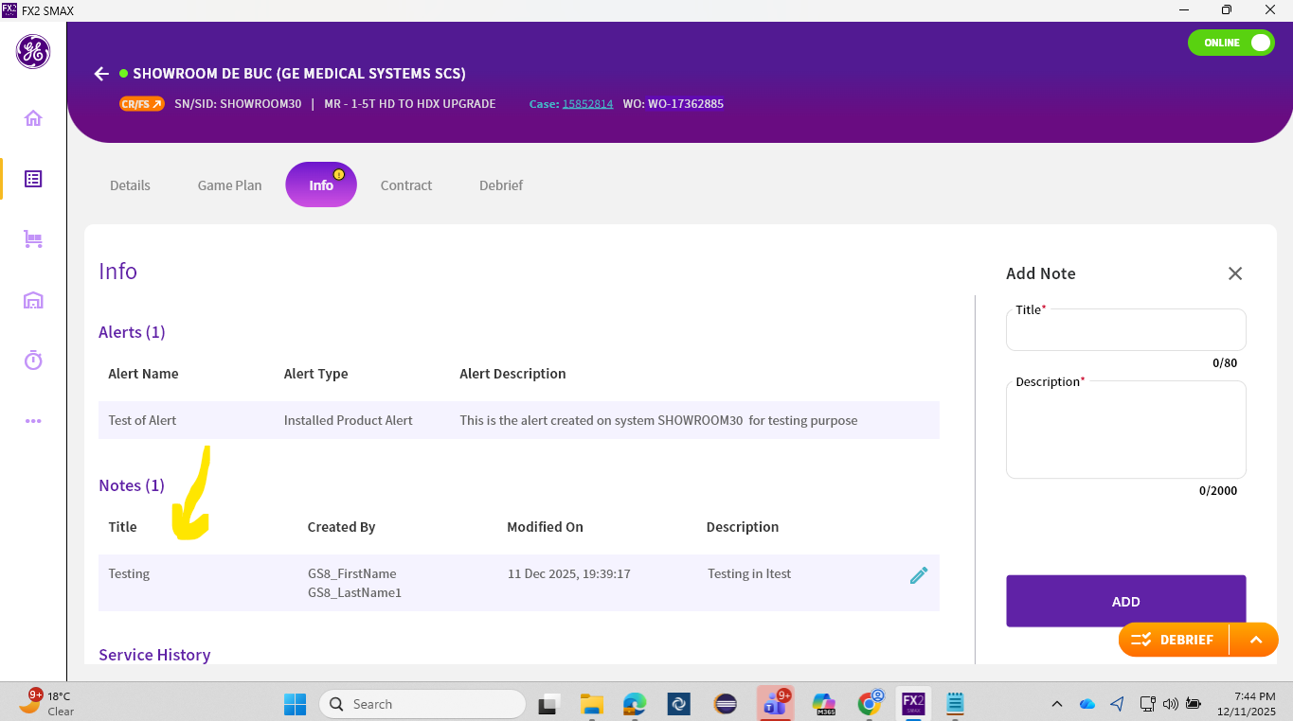  16: Click on back button and logout from the Fx2 Smax Windows application, User should be able to logout from the Fx2 Smax Windows application., RequiresObjectiveEvidence: Yes, Passed, User was able to logout from the Fx2 Smax Windows application.  Logout Date, Time and Time Zone was recorded as 11-Dec-2025 07:45 pm IST  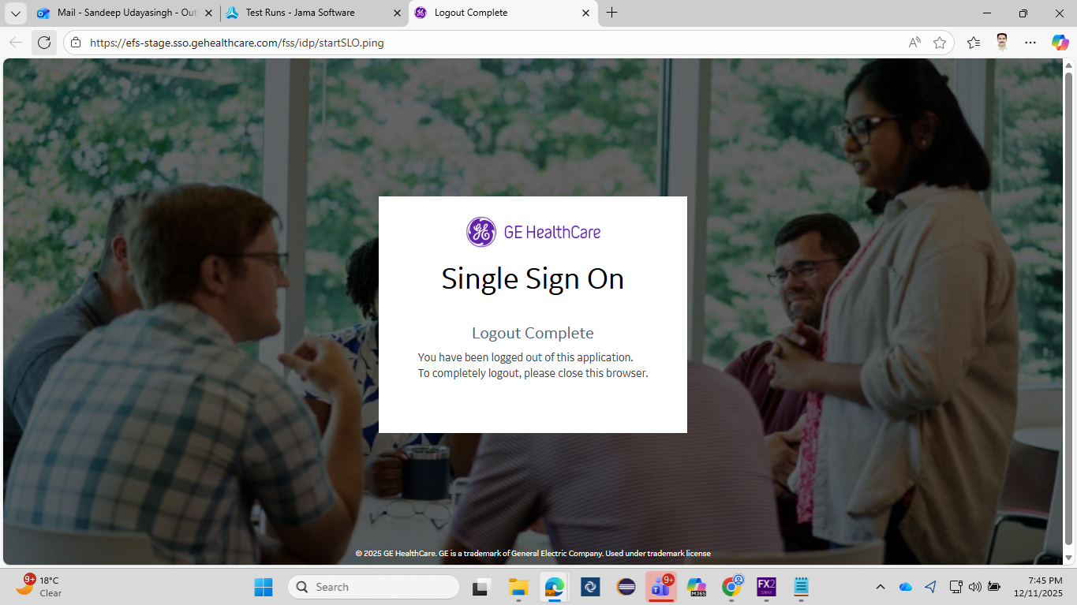
Actual Results
Status | Passed
Pass with Errors | No
Global ID | GID-TSTRN-806059
Test Executor

